Quiz#7
Section: __________________________ Group: _______________________
Name(print): ______________________________ Student ID: _________________________
- A skier starts from rest at a certain height above the end of a ski jump ramp (see figure) and then leaves the ramp. While descending, the skier experiences friction on the surface of the ramp, but air resistance can be ignored. Considering the motion from when the skier begins moving until just before leaving the ramp, which of the following statements is correct?

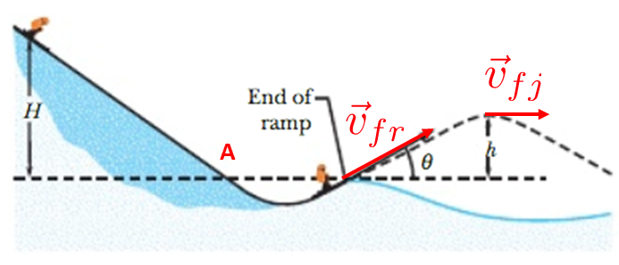
- The force of gravity does negative work.
- The frictional force does negative work.
- The skier's gravitational potential energy is increasing.
- The frictional force does positive work.

- An object can escape a planet with radius R and mass M at an escape speed given by $v=\sqrt{{2GM}/R}$, where $G$ is the universal gravitational constant. Based on this expression for escape speed, which of the following statements is correct?
- A heavier object requires a higher speed to escape from the planet.
- A lighter object requires a lower speed to escape from the planet.
- An object requires a higher speed to escape from a planet with smaller mass and a larger radius.
- An object requires a higher speed to escape from a planet with greater mass and a smaller radius.

- The force $\vec{F}=\left(3.04N\right)\hat{i}+\left(4.01N\right)\hat{j}$. acts on a particle as it moves along the x axis from x = 0.33 m to x = 5.03 m. What is the work, in joules, done by the force on the particle?
- 20.5 J
- 14.3 J
- 5.00 J
- 35.7 J

